

+

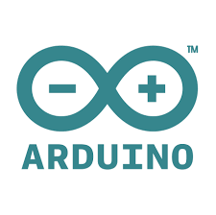

Runnings tests and analyzing data from XoNano impact foam and your Arduino Uno